

**Faculty of engineering - Shoubra**

**Benha University**

|  |  |
| --- | --- |
| **Name** | **Nourhan maher Mohamed** |
| **Edu mail** | **Nourhan196134@feng.bu.edu.eg** |
| **Course name** | **Computer** |
| **Course code** | **ECE001** |
| **Topic** | **Artificial Intelligence** |
| **B.N** | **1007** |
| **Github link** | [**https://github.com/nourhan-maher/ECE001-Artificial-Intelligence-**](https://github.com/nourhan-maher/ECE001-Artificial-Intelligence-) |
| **Github page** | [**https://nourhan-maher.github.io/ECE001-Artificial-Intelligence-/**](https://nourhan-maher.github.io/ECE001-Artificial-Intelligence-/) |

**Approved by:**

|  |  |
| --- | --- |
| Examiners committee | Signature |
| Dr. Ahmed Bayoumi |  |
| Dr. Shady Elmashad |  |
| Dr. Abd-El-Hamed Attaby |  |

**A Brief Profile of Artificial Intelligence**

* **What is Artificial Intelligence?**

Artificial intelligence (AI) is the simulation of human intelligence processes by machines, especially computer systems. Specific applications of AI include [expert systems](https://searchenterpriseai.techtarget.com/definition/expert-system), natural language processing ([NLP](https://searchbusinessanalytics.techtarget.com/definition/natural-language-processing-NLP)), Speech recognition and [machine vision](https://searchenterpriseai.techtarget.com/definition/machine-vision-computer-vision).

* **How does Artificial Intelligence work?**

There are four different approaches that have historically defined the field of AI: 1- Thinking humanly – 2- Thinking rationally – 3- Acting humanly – 4- Acting rationally. **AI** is the endeavor to replicate or simulate human intelligence in machines.

* **The advantages and Disadvantages of Artificial Intelligence:**

|  |  |
| --- | --- |
| Advantages | Disadvantages |
| Solving new problems | Expensive to implement |
| Less room for errors | Leads to unemployment |
| Doesn’t get tired and wear out easily | Lacks in creativity |

* **Application of Artificial Intelligence:**

We can use AI in many fields like Health care, business, **Autonomous vehicles** education and in robots etc… ,We all heard about the robot Sophia which is became famous in all world as an application on AI and this leads us to ask, How far can Artificial Intelligence reach in the future ?!

**Source code**

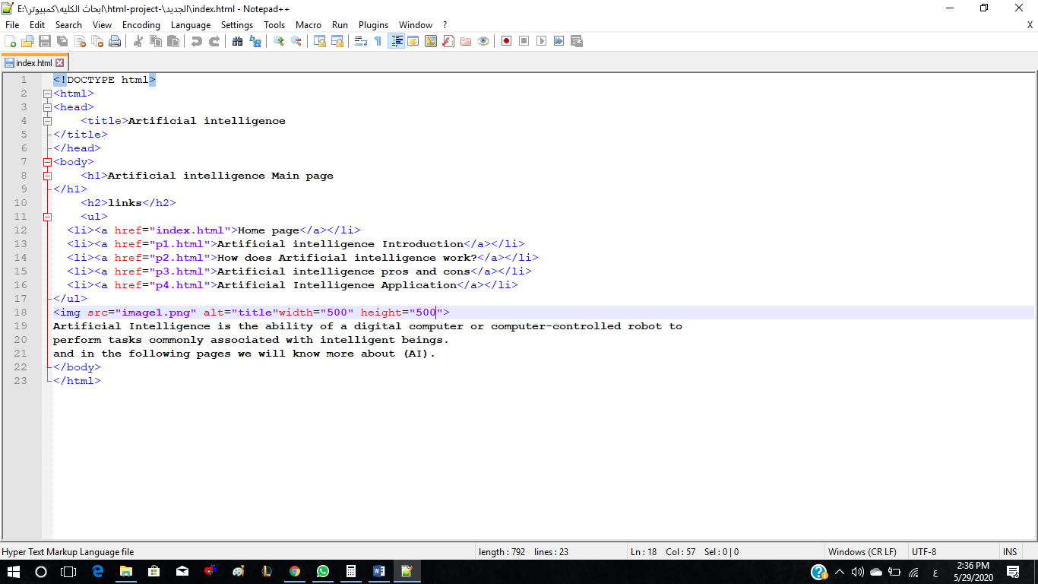

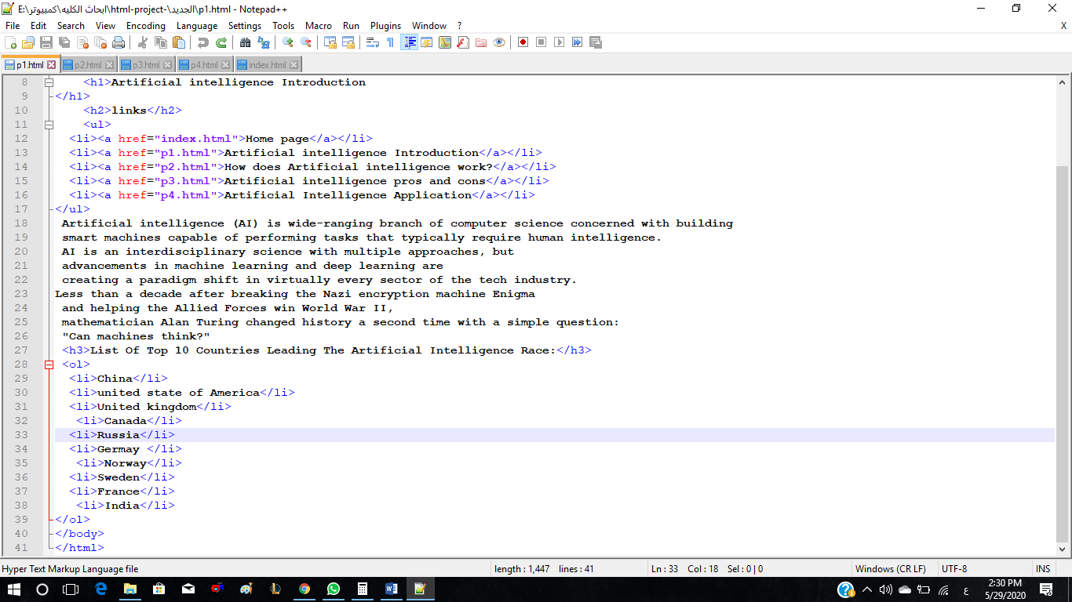

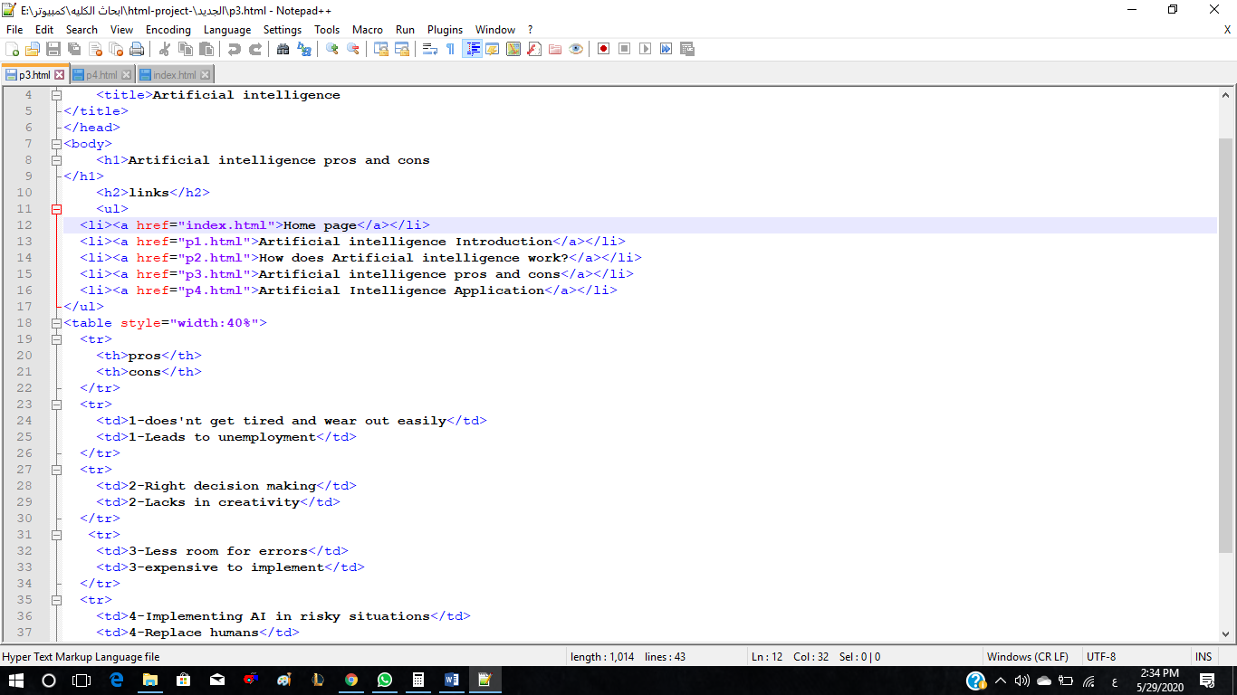

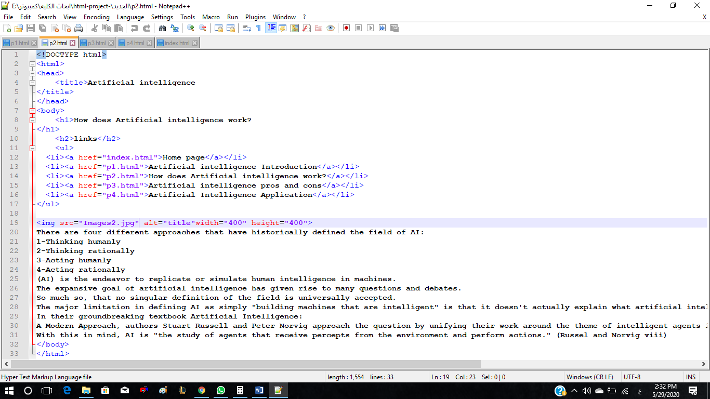

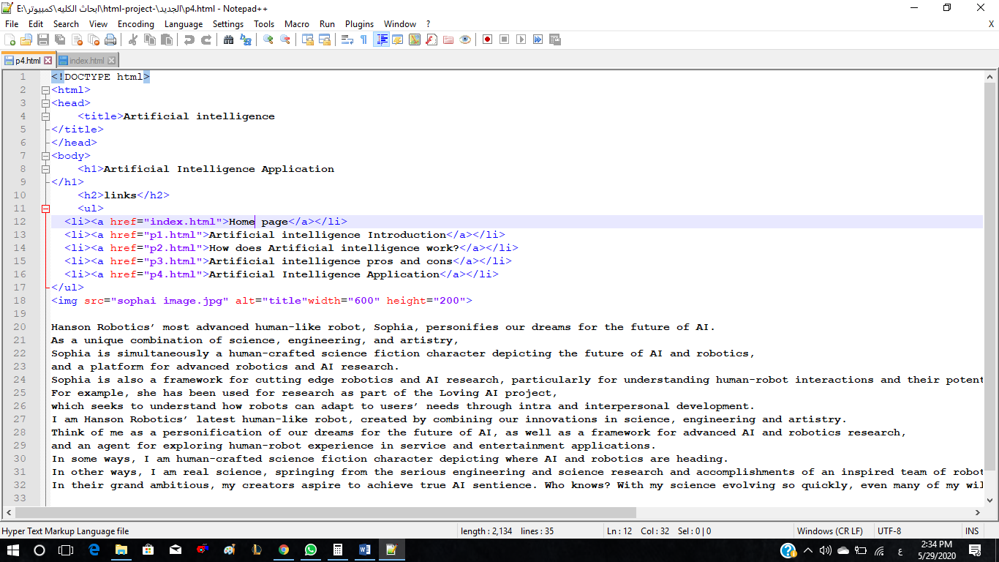

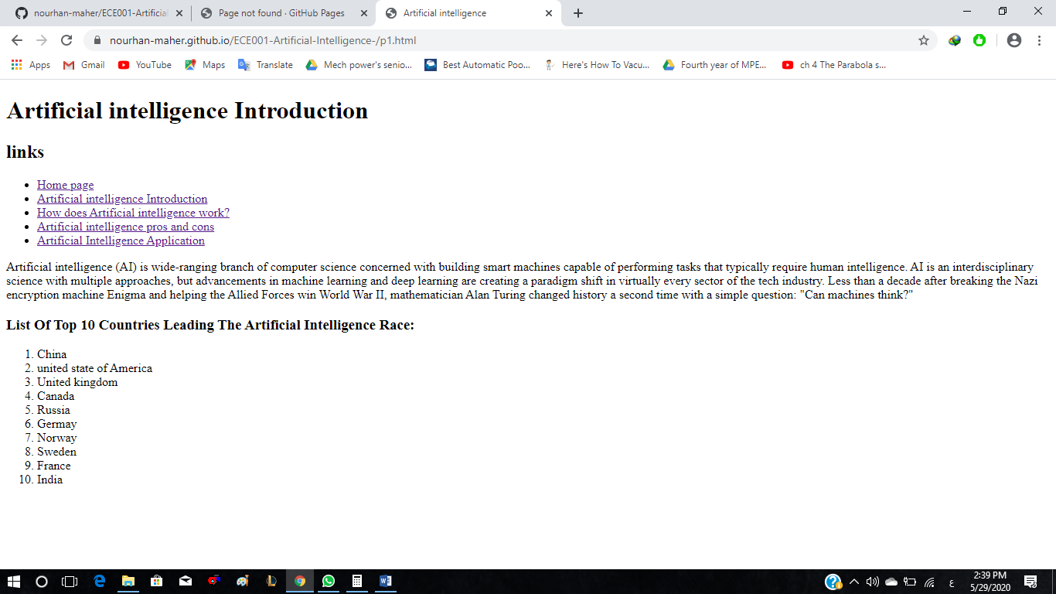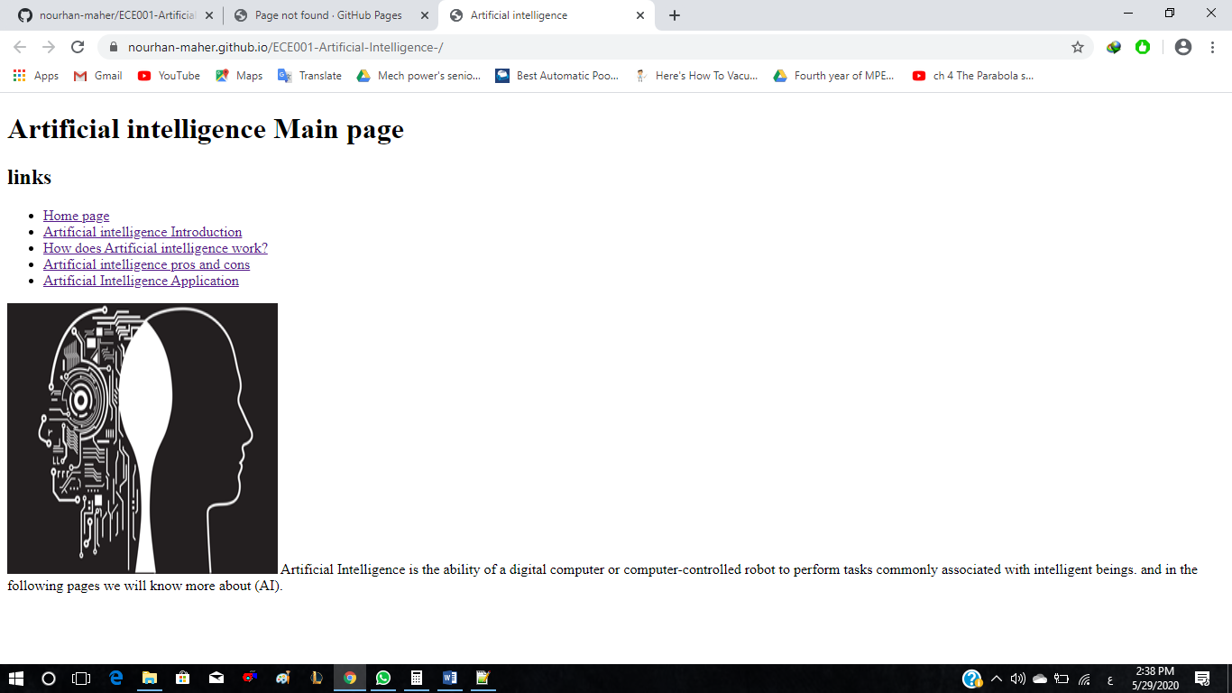**Screenshots of the website**

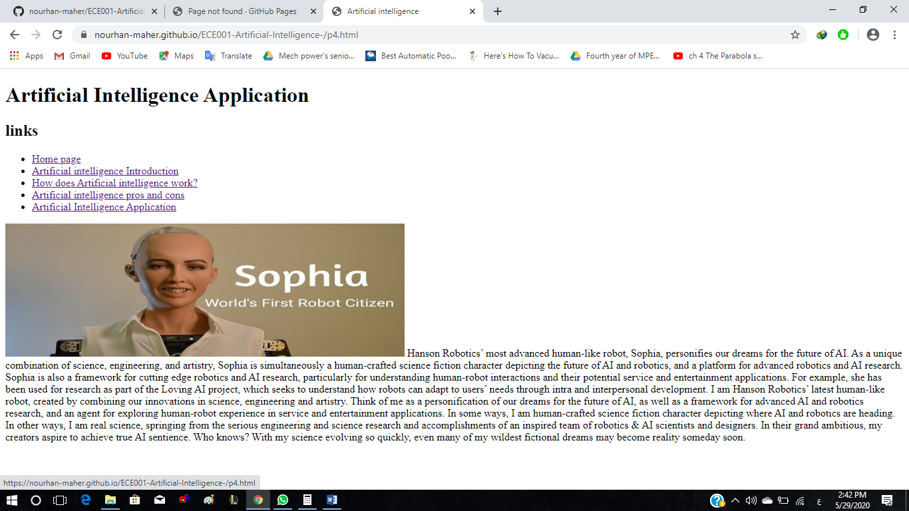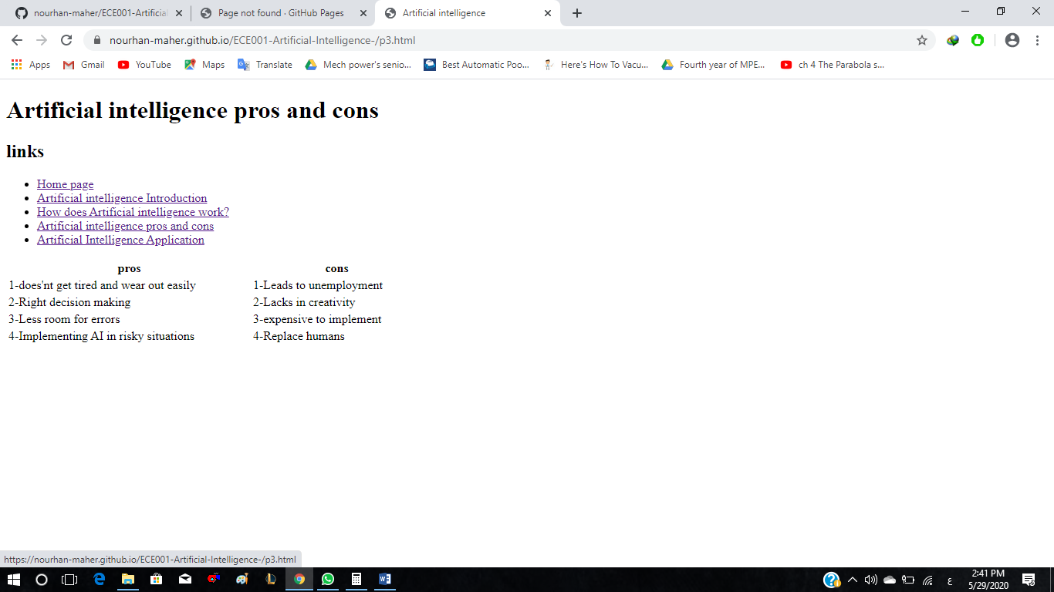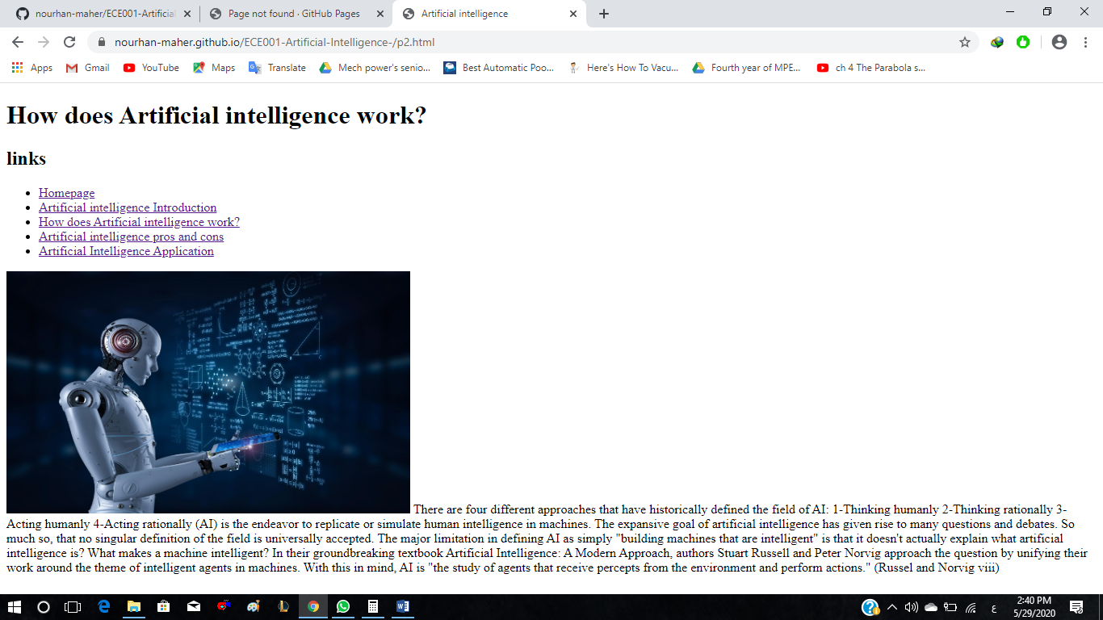

**References**

1. <https://www.innoplexus.com/blog/how-artificial-intelligence-works/>
2. <https://www.valluriorg.com/blog/artificial-intelligence-and-its-applications/>
3. <https://searchenterpriseai.techtarget.com/definition/AI-Artificial-Intelligence>